**COLLEGER**

**A Mini-Project Report**

**Under**

**IMPLEMENTATION OF TECHNOLOGY**

***Submitted by***

**TANUVI SABOO**

**VAIBHAV YADAV**

**VISHAL THANVI &**

**YASH PATTANI**

***Under The Guidance Of***

**PROF .RATNESH CHATURVEDI**

***in partial fulfillment for the award of the degree***

***of***

**MBATech**

**IN COMPUTERS**



**at**

**nmIMS’S mUKESH PATEL SCHOOL OF TECHNOLOGY MANAGEMENT & eNGINEERING, mUMBAI**

**APRIL, 2016**

***CERTIFICATE***

This is to certify that the project entitled **Colleger** is the bonafide work carried out by **Tanuvi Saboo,Vaibhav Yadav ,Vishal Thanvi and Yash Pattani** of MBATech (Computer Engineering), MPSTME (NMIMS), Mumbai, during the fourth semester of the academic year 2015-2016, in fulfillment of the requirements for the award of the Degree of MBAtech as per the norms prescribed by NMIMS. The project work has been assessed and found to be satisfactory.

___________________

Ratnesh Chaturvedi

Internal Mentor

_______________________ ___________________

Examiner 1 Examiner 2

________________________

Dean

Dr. Sharad Y .Mhaiskar

***DECLARATION***

We, Tanuvi Saboo, Vaibhav Yadav , Vishal Thanvi and Yash Pattani of MBATech (Computer Engineering), semester- IV, understand that plagiarism is defined as anyone or combination of the following:

1. Un-credited verbatim copying of individual sentences, paragraphs or illustration (such as graphs, diagrams, etc.) from any source, published or unpublished, including the internet.

2. Un-credited improper paraphrasing of pages paragraphs (changing a few words phrases, or rearranging the original sentence order)

3. Credited verbatim copying of a major portion of a paper (or thesis chapter) without clear delineation of who did wrote what.

4. We have made sure that all the ideas, expressions, graphs, diagrams, etc., that are not a result of our work, are properly credited. Long phrases or sentences that had to be used verbatim from published literature have been clearly identified using quotation marks.

5. We affirm that no portion of my work can be considered as plagiarism and we take full responsibility if such a complaint occurs. We understand fully well that the guide of the seminar/ seminar report may not be in a position to check for the possibility of such incidences of plagiarism in this body of work.

Signature of the Students:

___________ ____________ ___________ ___________

Name: ___________ ____________ ___________ ___________

Roll No. ___________ ____________ ___________ ___________

Place: Mumbai

Date: April 2016

***ACKNOWLEDEMENT***

We have taken efforts in this project. However, it would not have been possible without the kind support and help of many individuals. We would like to extend our sincere thanks to all of them.

We are highly indebted to Prof. Ratnesh Chaturvedi for his guidance and constant supervision as well as for providing necessary information regarding the project & also for his support in completing the project.

We would like to express our gratitude towards our parents for their kind co-operation and encouragement which helped us in completion of this project.

Our thanks and appreciations also go to our batch mates in developing the project and people who have willingly helped us out with their abilities.

**Abbreviations**

|  |  |
| --- | --- |
| **Abbreviation** | **Description** |
| ADB | Android Debugging Bridge |
| ADT | Android Development Tools |
| Android SDK | Android Software Development Kit |
| ART | Android Runtime |
| CPU | Central Processing Unit |
| GPU | Graphic Processing Unit |
| IPS | In-Plane Switching |
| LCD | Liquid Crystal Display |
| RAM | Random Access Memory |
| SQL | Structured Query Language |
| XML | Extensible Markup Language |

***ABSTRACT***

Modern hand held devices such as smart phones and PDAs have become increasingly powerful in recent years. Dramatic breakthroughs in processing power along with the number of extra features included in these devices have opened the doors to a wide range of commercial possibilities. In particular, most cell phones regularly include cameras, processors comparable to PCs from only a few years ago, and internet access. However, even with all these added abilities, there are few applications that allow much passing of the environmental information and location based services.

As mobile devices become more like PCs they will come to replace objects we tend to carry around such as checkbooks, credit cards, cameras, planners, mp3 players, etc. In short, we will be using them to accomplish our daily tasks. One application that falls into this category is the COLLEGER developed for Android Phones.

The prime objective of COLLEGER is to create a full fledged Android application which that enables and helps users from college committees promote their apps and enables other college students to receive information about any upcoming events in their or other colleges.. The users can login into the app by registering. The user can find all the upcoming events listed according to the starting date of event or as per filters applied . The admin of an event can create a full fledged page containing all relevant information about the event.

The Project is developed in Java Programming Language by using the Android Studio Integrated Development Environment (IDE). We used the Android Software Development Kit (SDK) which includes a variety of custom tools that help us develop mobile applications on the Android platform. The most important of these are the Android Emulator, HXAM Accelerator and the Android Development Tools (ADT) packages for Android Studio.

**Table of contents**

**CHAPTER NO. TITLE PAGE NO.**

List of figures 8

Abbreviations 5

Abstract 6

1. INTRODUCTION 9

1.1 Project Overview 11

1.2 Hardware Specification 12

1.3 Software Specification 13

1.4 Review of literature 14

2. ANALYSIS & DESIGN 15

3. METHODS IMPLEMENTED 26

4. RESULTS & DISCUSSION 27

5. CONCLUSION & FUTURE SCOPE 28

6. REFERENCES 29

***LIST OF FIGURES***

**CHAPTER NO. TITLE PAGE NO.**

1. INTRODUCTION

Fig 1 - Android Architecture Diagram 9

2. ANALYSIS AND DESIGN

Fig 2 - Screenshot_AppOnPhone 15

Fig 3 - Screenshot_MainActivity 16

Fig 4 - Screenshot_SignIn 17

Fig 5.1 - Screenshot_RegisterPage1 18

Fig 5.2 - Screenshot_RegisterPage2 19

Fig 5.3 - Screenshot_RegisterPage3 20

Fig 6 - Screenshot_ListOfEvent 21

Fig 7.1 - Screenshot_Event1 22

Fig 7.2 - Screenshot_Event2 23

Fig 7.3 - Screenshot_Event3 24

Fig 7.4 - Screenshot_Event4 25

***INTRODUCTION***

**Introduction to Android:**

Android is an open source and Linux-based operating system for mobile devices such as smart phones and tablet computers. Android was developed by the Open Handset Alliance, led by Google, and other companies.

Android provides a rich application framework that allows you to build innovative apps and games for mobile devices in a Java language environment.

Android Architecture:

Android operating system is a stack of software components which is roughly divided into five sections and four main layers as shown below in the architecture diagram.

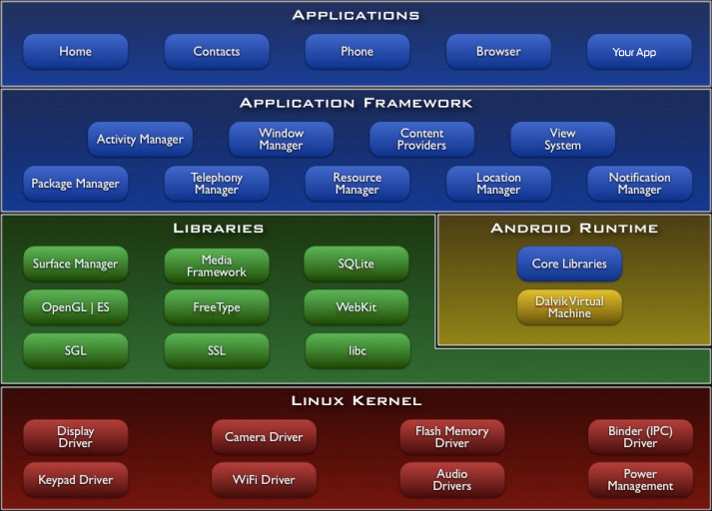

Fig 1.1

Android gives you a world-class platform for creating apps and games for Android users everywhere, as well as an open marketplace for distributing to them instantly. Android operating system is a stack of software components which is roughly divided into five sections and four main layers as shown below in the architecture diagram.

You will find all the Android application at the top layer. You will write your application to be installed on this layer only. Examples of such applications are Contacts Books, Browser, Games etc. These comprise both the native applications provided with the particular Android implementation (for example web browser and email applications) and the third party

applications installed by the user after purchasing the device. Applications created by third party users or developers will be installed here.

**Introduction to Application:**

Colleger is an app on the android platform that enables and helps users from college committees promote their apps and enables other college students to receive information about any upcoming events in their or other colleges.

The app’s purpose is to promote college events and ease the information flow between the students and the committee members from different colleges within a locality. It will also give a new way of promoting events rather than the usual posters and class announcements which can be tedious for both the promoters and the students.

The app is useful for all college students and allows the students to filter the event according to their interests. For example, marketing related events, sports, debates, college fests. Whereas the committee users can list all their upcoming and past events and upload information such as digital posters, dates, information on the events itself, and other useful information. The committee members can also upload registration links and contact information if they wish to.

The organizers can post the digital posters of their events on the app and the students

subscribed to the committee can view them at their convenience. Students can post

their queries in the comment section and the organizers can answer them easily without

having to make any extra effort

Project Overview:

Colleger is a developing android application that will power fast & convenient way for college going students to be up to date with upcoming and on going events around them . We at Colleger aim to build a platform for simplified Publicity of events to a larger audience as well as have a list of events on user’s preferred topic just a touch away.

Hardware Specification

Colleger is not a hardware intensive application, thus requires very basic level of hardware, as its application ranges across all devices, low end to high end, phones to tablets. Thus, the following are the minimum hardware specifications required to run the application:

* Processor:
  + Quad-core 1.2 GHz
  + PowerVR SGX 540 GPU.
* Memory:
  + 768 MB RAM
  + 1 GB of Flash Memory
  + Micro-SD card slot (Optional)
* Screen:
  + 3.5-inch LCD display
  + Capacitive or Resistive touch

During Development of the application, a Nexus 4 was used to develop and test the application.

Software Specification

Colleger is designed to work on Android 4.0, Ice Cream Sandwich and above.

Apart from Android 4.0 and above, the application, like most android applications can run on the following Operating Systems:

* Blackberry OS 11
* Sailfish OS
* Chrome OS
* Color OS
* INUI OS
* YUN OS
* Nokia X mobile Platform

Some of these are based on android, while some (Bbos 11, Sailfish OS) are made compatible to run android applications. Following is the list of Android versions on which Colleger has been tested:

* Android 4.0 (Ice Cream Sandwich)
* Android 4.2 (Jellybean)
* Android 4.3 (Jellybean)
* Android 4.4 (KitKat)
* Android 5.0 (Lollipop)
* Android 5.0.2 (Lollipop)
* Android 5.1 (Lollipop)

This gives the application a broad platform, as these operating systems are in majority of smart phones being used by prospective users.

The application needs an stable internet connection to run efficiently.

Review of Literature

A literature review is a text of a scholarly paper, which includes the current knowledge including substantive findings, as well as theoretical and methodological contributions to a particular topic. Most often associated with academic-oriented literature, such as a thesis, dissertation or a peer-reviewed journal article, a literature review usually precedes the methodology and results section although this is not always the case. Literature reviews are also common in a research proposal or prospectus. Its main goals are to situate the current study within the body of literature and to provide context for the particular reader. Literature reviews are a basis for research in nearly every academic field.

**Java:**

Java is a set of several computer software and specifications developed by Sun. Microsystems, later acquired by Oracle Corporation, that provides a system for developing application software and deploying it in a cross-platform computing environment. Java is used in a wide variety of computing platforms from embedded devices and mobile phones to enterprise servers and supercomputers. While less common, Java applets run in secure, sandboxed environments to provide many features of native applications and can be embedded in HTML pages.

Writing in the Java programming language is the primary way to produce code that will be deployed as byte code in a Java Virtual Machine (JVM); byte code compilers are also available for other languages, including Ada, JavaScript, Python, and Ruby. In addition, several languages have been designed to run natively on the JVM, including Scala, Clojure and Groovy. Java syntax borrows heavily from C and C++, but object-oriented features are modeled after Smalltalk and Objective-C.Java eschews certain low-level constructs such as pointers and has a very simple memory model where every object is allocated on the heap and all variables of object types are references. Memory management is handled through integrated automatic garbage collection performed by the JVM.

***ANALYSIS & DESIGN***

During the conception of the application, the requirements were mapped out first. This included analyzing the need of this application, its features and figuring out a list of functions it would perform during operation. This largely consisted of the analysis.

After performing a complete analysis, the design of the application was pursued. Abnegate was designed using material design. Material design is a comprehensive guide for visual, motion, and interaction design across platforms and devices.

## Features:

* User-Friendly app Light-Weight

**Fig 2: App on Phone Menu**

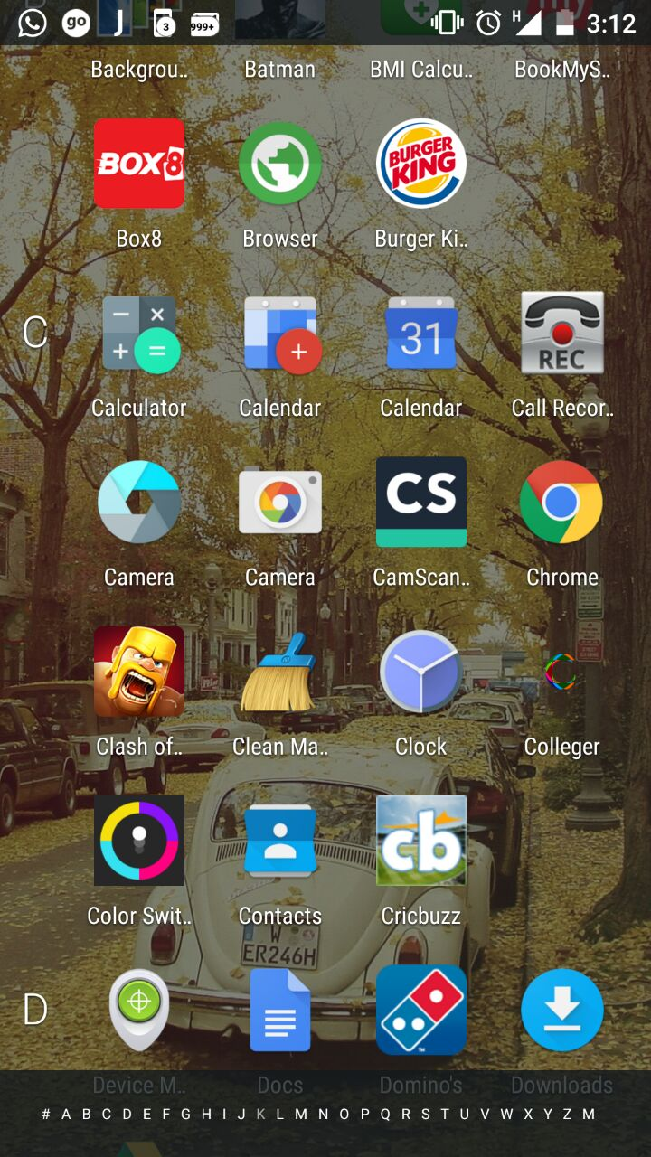

**Fig 3: Main Activity**

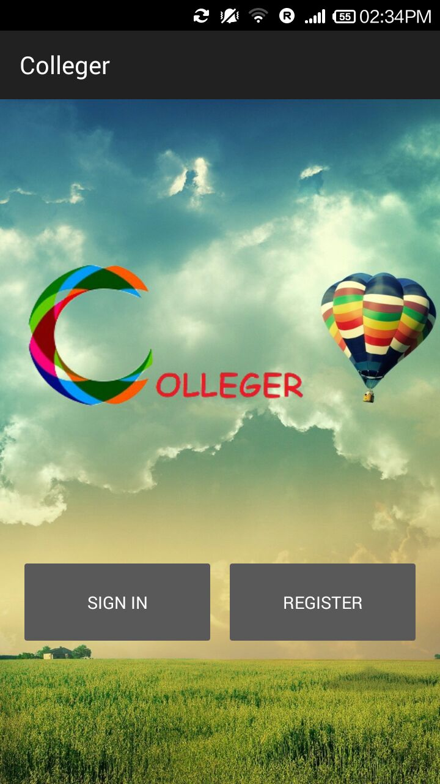

**4: Login Screen**

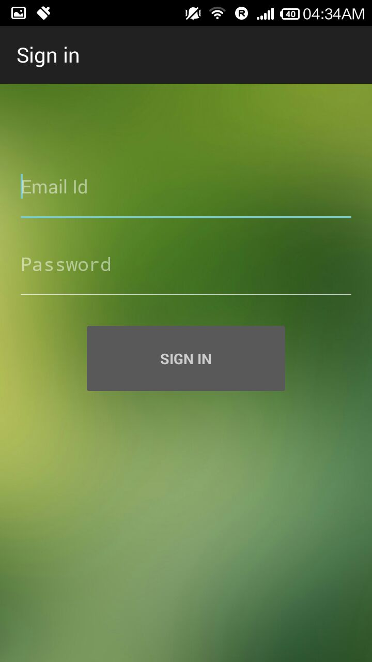

**Fig 5.1: Register Screen**

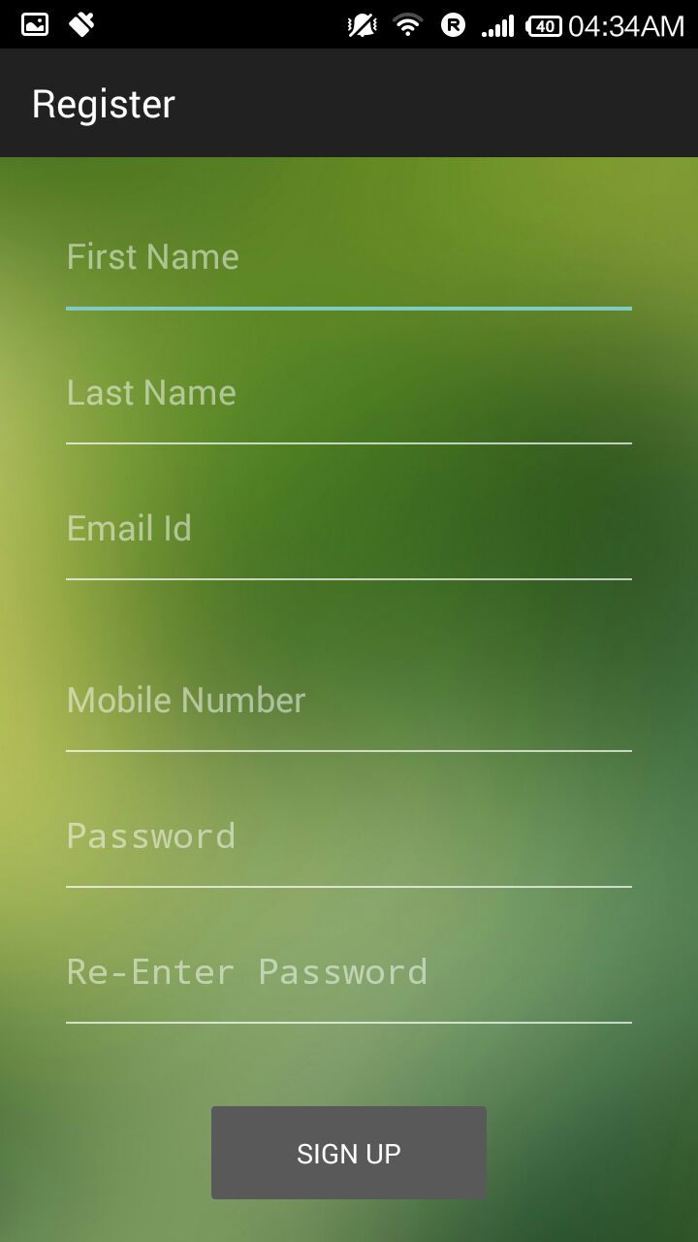

**Fig 5.2: Register Screen**

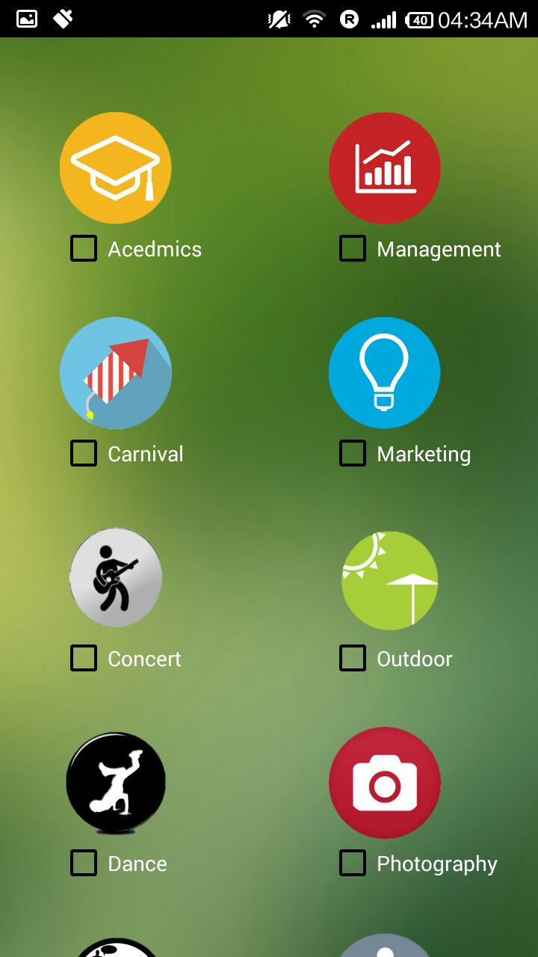

**Fig 5.3: Register Screen**

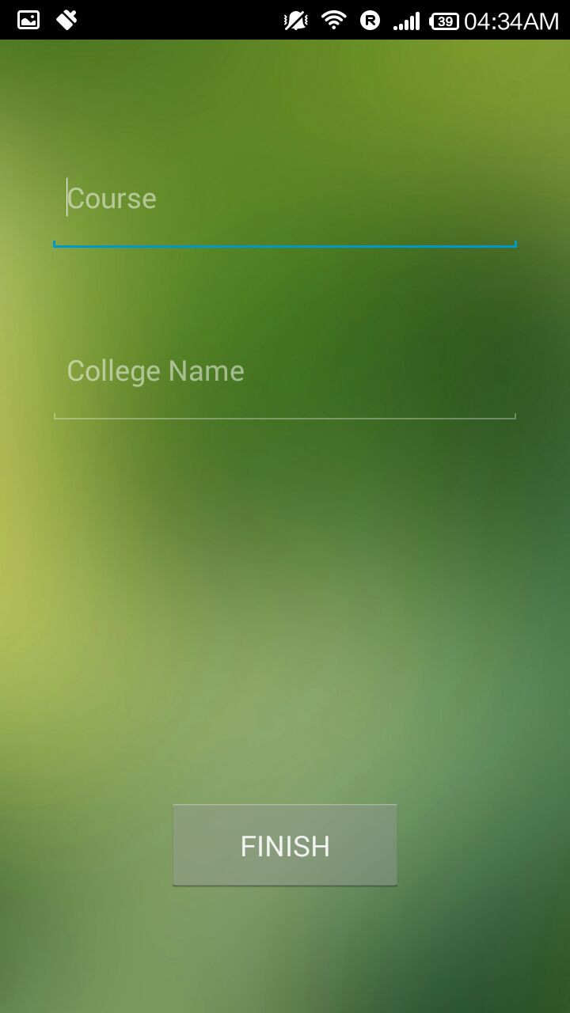

**Fig 6: List Of Events Screen**

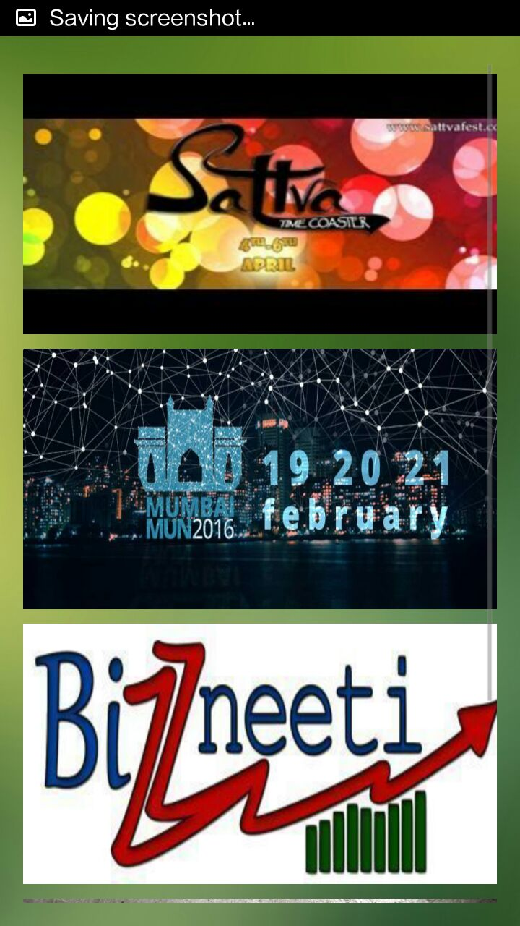

**Fig 7.1 : Event 1 Screen**

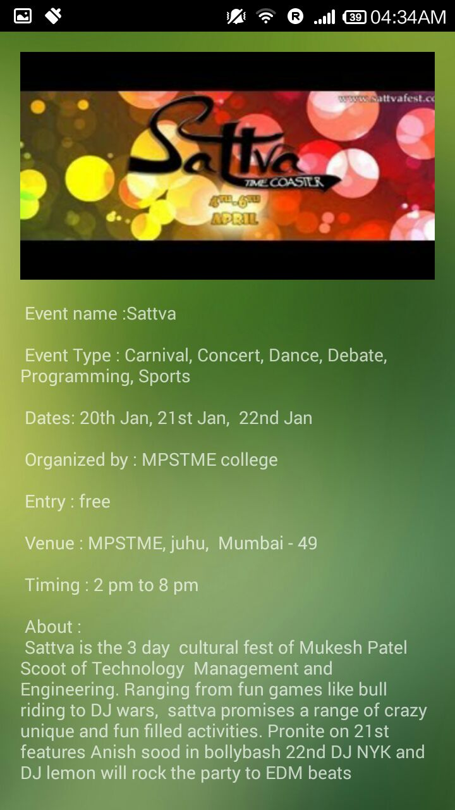

**Fig 7.2 : Event 2 Screen**

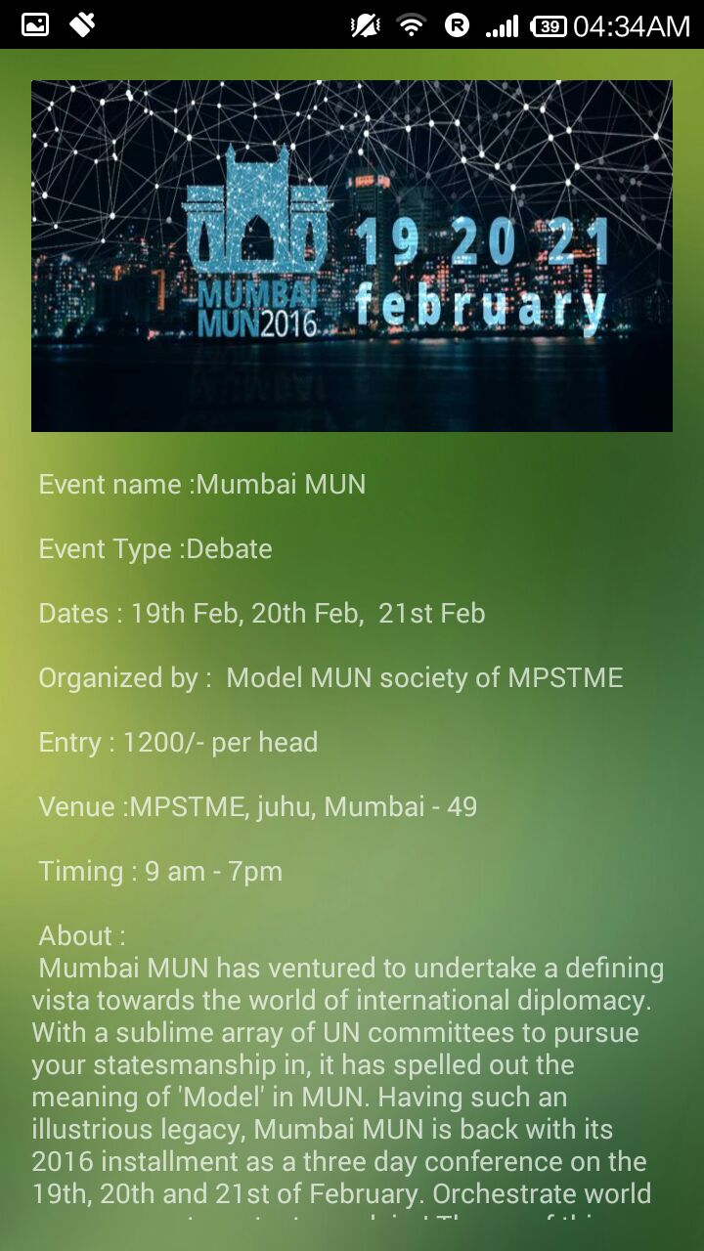

**Fig 7.3 : Event 3 Screen**

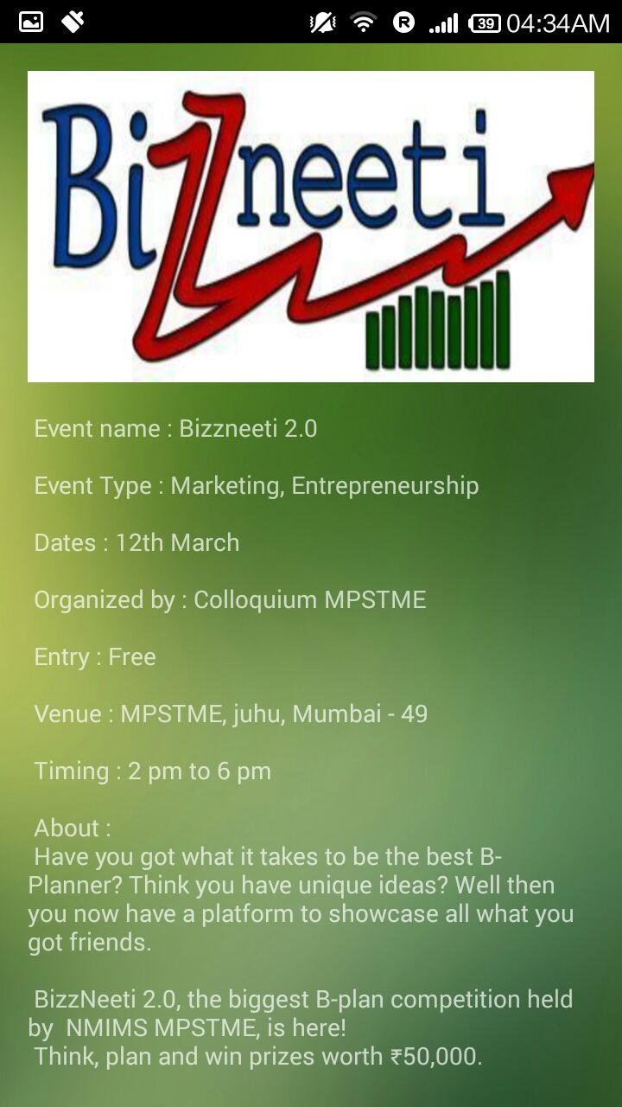

**Fig 7.4 : Event 4 Screen**

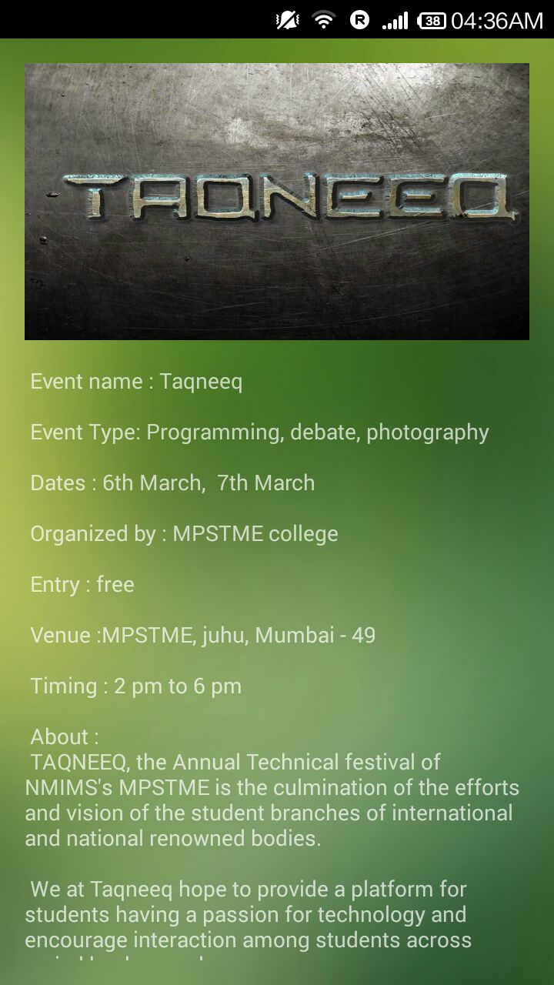

***METHODS IMPLEMENTED***

**Android Studio:**

Android Studio is the official IDE for Android application development, based on IntelliJ IDEA. On top of the capabilities you expect from IntelliJ, Android Studio offers:

Flexible Gradle-based build system.

Build variants and multipleapk file generation.

Code templates to help you build common app features.

Rich layout editor with support for drag and drop theme editing lint tools to catch performance, usability, version compatibility, and other problems.

ProGuard and app-signing capabilities.

Built-in support for Google Cloud Platform, making it easy to integrate Google Cloud.

Messaging and App Engine.

***RESULTS AND DISSCUSSION***

The main frame of the application has been created . A user can create a profile and view events Internally a lot of features can be still accommodated .We are yet to take the App online . Evevy app needs to be updated with new features and we will continue to upgrade the app with new features and building more user friendly screens for this app.

***CONCLUSION & FUTURE SCOPE***

->The app is yet to be taken online .

-> User database is yet to be created.

-> Filters are not added to the events .

-> More categories can be added to the event types .

->The app is long way from being complete and we will continue to put in effort.

***REFERENCES***

1. Videos provided in course
2. [www.youtube.com](http://www.youtube.com)
3. developer.android.com
4. [www.google.com](http://www.google.com)
5. ibuild**app**.com
6. ww.codeschool.com